Epsom & Ewell F.C.
22
v
Westfield F.C.
Saturday, 18th February 2017 – 3.00 p.m.
Good afternoon! We welcome the players, supporters and officials of Westfield Football Club, today’s officials and our own regular people for today’s League match.

Our opponents present us with a tough challenge this afternoon. They are having a great season and are well placed to take advantage of any slip ups by the leaders Hartley Wintney, whether they happen to be on, or off the field. We have already met once this season, losing 2-1 at Woking Park and I personally thought their first half performance against us was the best I’d seen against us by a Step Five team in years as we hardly got a sniff. We ran them closer in the second half and I believe we are much stronger now than we were back then and we’ll have to be if we are to secure the win we require if we have any designs on catching them for second place at the end of the season.

We were last here two weeks ago when we led early against Badshot Lea but two rather odd officiating decisions, or should I say, non-decisions, left us trailing. Fortunately, we levelled things up before half time and were well on top in the second half, eventually coming through 4-2. You could see that they were an improving team with some new faces and this played out on Saturday when they defeated Walton & Hersham; a result that did us a lot of favours.

We then travelled to Chertsey Town where we put in a very good performance and handed them a 3-0 win on their own patch. They had been in decent form and had also defeated today’s opponents there last month, so our result stands up well. We followed that with a trip to the Orchard, home of Bedfont & Feltham for a match against their tenants CB Hounslow United on Tuesday evening, and produced a tremendous result, winning 2-0 there despite a substantial number of absences and having to play the last 25 minutes with ten men.

We now know that our League Cup Semi-Final opponents will be Windsor and the match will take place at High Road on 21st March. Our other rearranged match with Bedfont Sports will now take place next door to their ground at Bedfont & Feltham FC on Wednesday 15th March, so please make a note of note of these dates. It will of course be our third visit there this season!

We have no real break after this match as we visit Abbey Rangers on Monday night, keen to get some revenge for our harsh F.A. Vase defeat and we follow this with a trip to Spelthorne Sports next Saturday, returning here two weeks today for the visit of Walton & Hersham. All of these matches are very difficult so why not come along and give the lads your support?

Enjoy the game!

Rich

You can follow us on Facebook: www.facebook.com/epsomandewellfc
Twitter: @EEFCOfficial Instagram at: www.instagram.com/epsomandewellfc
and on Youtube at: www.youtube.com/channel/UCtLrpS0x5OaYUACRT34_zng

Today’s Cover Photos

- Daryl Cooper-Smith scores our second goal at Chertsey on Saturday with a great bit of skill

- Matt Ferdinando scores our equaliser in the League Cup Quarter Final at Walton & Hersham

Cherry Red Records Combined Counties League
Premier Division Table 2016/17
inc Weds 15th February | P | W | D | L | F | A | Pts | GD | H | A
Hartley Wintney | 33 | 27 | 4 | 2 | 115 | 34 | 85 | +81 | 18/3 | 1-3
Hanworth Villa | 32 | 19 | 5 | 8 | 58 | 36 | 62 | +22 | 2-2 | 0-1
Westfield | 29 | 18 | 7 | 4 | 66 | 33 | 61 | +33 | 18/2 | 1-2
Epsom & Ewell | 31 | 16 | 7 | 8 | 68 | 41 | 55 | +27 | X | X
Walton & Hersham | 31 | 14 | 12 | 5 | 52 | 35 | 54 | +17 | 4/3 | 1-1
Camberley Town | 30 | 16 | 4 | 10 | 61 | 36 | 52 | +25 | 0-0 | 1/4
Horley Town | 29 | 15 | 5 | 9 | 66 | 48 | 50 | +18 | 3-0 | 17/4
Knaphill | 30 | 14 | 3 | 13 | 58 | 56 | 45 | +2 | 4-0 | 8/4
Abbey Rangers | 31 | 13 | 6 | 12 | 54 | 57 | 45 | -3 | 7-1 | 20/2
Windsor | 31 | 12 | 7 | 12 | 59 | 52 | 43 | +7 | 2-0 | 1-2
Bedfont Sports | 28 | 12 | 6 | 10 | 48 | 52 | 42 | -4 | 5-1 | 15/3
Guildford City | 34 | 12 | 6 | 16 | 65 | 71 | 42 | -6 | 1-0 | 2-0
Spelthorne Sports | 31 | 12 | 5 | 14 | 58 | 58 | 41 | 0 | 3-2 | 25/2
Colliers Wood United | 29 | 10 | 8 | 11 | 48 | 49 | 38 | -1 | 14/4 | 0-5
North Greenford United | 27 | 11 | 4 | 12 | 56 | 53 | 37 | +3 | 22/4 | 1-2
AFC Hayes | 32 | 10 | 7 | 15 | 49 | 59 | 37 | -10 | 2-2 | 0-1
CB Hounslow United | 31 | 11 | 3 | 17 | 44 | 62 | 36 | -18 | 1-5 | 2-0
Sutton Common Rovers | 27 | 10 | 4 | 13 | 40 | 47 | 34 | -7 | 2-1 | 1-1
Farnham Town | 31 | 9 | 5 | 17 | 44 | 65 | 32 | -21 | 25/3 | 2-1
Chertsey Town | 31 | 8 | 6 | 17 | 39 | 74 | 30 | -35 | 2-1 | 3-0
Raynes Park Vale | 30 | 5 | 7 | 18 | 37 | 68 | 22 | -31 | 1-1 | 1-1
Badshot Lea | 32 | 6 | 4 | 22 | 44 | 92 | 22 | -48 | 4-2 | 4-1
Bedfont & Feltham | 30 | 5 | 5 | 20 | 40 | 91 | 20 | -51 | 7/3 | 9-2

Lucky Day? – 18th February
Played 11 - Won 4 Drawn 2 Lost 5 - For 13 Against 24 - PPG 1.27 - Below Average
Our Club record against today’s opponent
Played 19 - Won 11 Drawn 3 Lost 5 - For 40 Against 31 - PPG 1.89 - Good
Our Largest wins and losses against today’s opponent
21st October 1967 - W 6-1 - Amateur Cup Second Qualifying Round (H)
31st October 1964 - L 1-5 - Surrey Senior Cup Second Qualifying Round (A)
Their Last Visit
25th March 2016 - Lost 0-2 - Combined Counties League

Birthday Corner
We have a couple of birthday celebrations this month, just two days apart and both players reached their 20th birthdays!

On 9th February Jordan Gallagher left his teens behind. He joined us from Leatherhead in the summer and has gradually moved from being a regular substitute to a reliable starter and as I write, he has actually played in more matches than anyone this season with 39, also contributing 11 goals, the best and most important of which undoubtedly came at Walton & Hersham in the League Cup Quarter-Final.

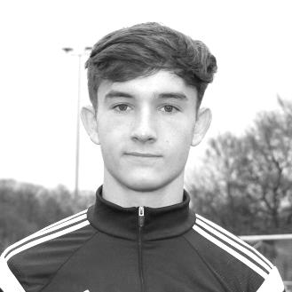
Adam Heagney also joined us from Leatherhead, and became a reliable part of our defence, slotting in at right back, although in recent matches has also found himself playing further forward. He has made 33 appearances so far and as you might expect for a full back, has yet to score, although he came mighty close at Chertsey Town last weekend, which would have been a great way to celebrate his birthday that day.

Congratulations to both and we hope you had great celebrations!

EL Records Premier Challenge Cup
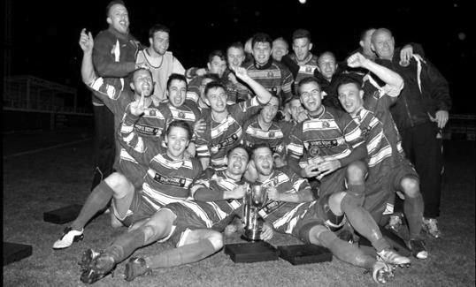
Quarter Finals
Windsor | 2-0 | Horley Town
Guildford City | 22/2 | Raynes Park Vale
Westfield | 4-1 | Camberley Town
Walton & Hersham | 1-3 | Epsom & Ewell
Semi Finals
Epsom & Ewell | 21/3 | Windsor
Guildford / Raynes Park | V | Westfield

Latest Results and Fixtures
Combined Counties League – Saturday 4th February
Abbey Rangers | 2-2 | Hartley Wintney
CB Hounslow United | 0-2 | Sutton Common Rovers
Epsom & Ewell | 4-2 | Badshot Lea
Guildford City | 2-0 | AFC Hayes
Spelthorne Sports | 4-0 | Camberley Town
Combined Counties League – Tuesday 7th February
Badshot Lea | 2-5 | Hanworth Villa
Camberley Town | 2-0 | Knaphill
Chertsey Town | 1-2 | Walton & Hersham
Spelthorne Sports | 2-3 | North Greenford United
Combined Counties League – Wednesday 8th February
Colliers Wood United | 3-0 | Farnham Town
Combined Counties League – Saturday 11th February
Badshot Lea | 4-3 | Walton & Hersham
Bedfont & Feltham | 4-2 | Horley Town
Chertsey Town | 0-3 | Epsom & Ewell
Colliers Wood United | 0-2 | Windsor
Farnham Town | 2-3 | Abbey Rangers
Hanworth Villa | 2-1 | Guildford City
Hartley Wintney | 6-1 | Raynes Park Vale
Knaphill | 1-2 | CB Hounslow United
Sutton Common Rovers | 0-1 | Bedfont Sports
Combined Counties League Cup QF – Tuesday 14th February
Westfield | 4-1 | Camberley Town
Combined Counties League – Tuesday 14th February
CB Hounslow United | 0-2 | Epsom & Ewell
Walton & Hersham | 1-1 | AFC Hayes
Combined Counties League – Wednesday 15th February
Colliers Wood United | 2-4 | Sutton Common Rovers
Combined Counties League – Saturday 18th February
Abbey Rangers | V | Hanworth Villa
Camberley Town | V | Colliers Wood United
CB Hounslow United | V | Hartley Wintney
Epsom & Ewell | V | Westfield
Farnham Town | V | AFC Hayes
Guildford City | V | Bedfont Sports
North Greenford United | V | Horley Town
Raynes Park Vale | V | Badshot Lea
Spelthorne Sports | V | Sutton Common Rovers
Walton & Hersham | V | Bedfont & Feltham
Latest Results and Fixtures
Combined Counties League – Saturday 18th February
Windsor | V | Chertsey Town
Combined Counties League – Monday 20th February
Abbey Rangers | V | Epsom & Ewell
Combined Counties League – Tuesday 21st February
Camberley Town | V | Westfield
Horley Town | V | Farnham Town
Combined Counties League Cup QF – Wednesday 22nd February
Westfield | V | Camberley Town
Combined Counties League – Saturday 25th February
AFC Hayes | V | Horley Town
Badshot Lea | V | Abbey Rangers
Bedfont & Feltham | V | Farnham Town
Bedfont Sports | prov | Camberley Town
Colliers Wood United | V | Walton & Hersham
Hanworth Villa | V | Raynes Park Vale
North Greenford United | V | Hartley Wintney
Spelthorne Sports | V | Epsom & Ewell
Sutton Common Rovers | V | Knaphill
Westfield | V | Guildford City
Windsor | V | CB Hounslow United
Combined Counties League – Monday 27th February
Abbey Rangers | V | North Greenford United
Sutton Common Rovers | V | Hanworth Villa
Combined Counties League – Tuesday 28th February
Knaphill | V | Bedfont Sports
Walton & Hersham | V | Raynes Park Vale
Westfield | V | Horley Town
Combined Counties League – Saturday 4th March
Camberley Town | V | Abbey Rangers
CB Hounslow United | V | Colliers Wood United
Chertsey Town | V | Badshot Lea
Epsom & Ewell | V | Walton & Hersham
Farnham Town | V | Hanworth Villa
Hartley Wintney | V | Windsor
Horley Town | V | Spelthorne Sports
Knaphill | V | Bedfont & Feltham
Raynes Park Vale | V | Bedfont Sports
Sutton Common Rovers | V | AFC Hayes
Westfield | V | North Greenford United

From behind the goal
Epsom & Ewell 4-2 Badshot Lea
Combined Counties League - Premier Division - Saturday 4th February 2017

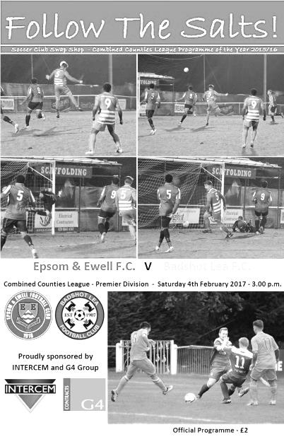
Late goals see off Baggies. Again!

Back in September we visited Ash United, the temporary home of Badshot Lea, where we were well in charge but required a couple of late goals to secure the 4-1 win that we deserved. It was a similar story on Saturday as we were the better side for much of the match, but required two late goals to break the deadlock once again after the teams had crossed over at 2-2.

We made one change from our win at Walton & Hersham with Matt Farrell returning from suspension for the unwell Alex McKay but you can always tell how strong we are by looking at our bench, and for this match it looked rather strong with regular full backs Adam Heagney and Matt Tanton, together with leading scorer Daryl Cooper-Smith and the fit again and lightning fast Ali Dewar also available.

We started well with Jason Nwachukwu getting into a good position in front of goal but he dragged his shot wide of the post and this was followed up by a long range shot from our Captain Dan Dean but this also went wide of visiting keeper Lee Allen's right hand post, although he would have plenty of work to do in due course.

We had a scare just before this when the Baggies floated a cross just over Michael Eacott's crossbar and then a sloppy pass from Craig Hastings let their striker through on goal but his shot was fairly comfortable for Eacott who made the save. He was busy again soon after to block a low shot after the visitors had again broken through on the right.

But any concerns were temporarily eased in the 19th minute when we took the lead. Nwachukwu was fed the ball out on the right and his first cross was a little too close to Allen who was able to parry it away but the ball was returned to the same player and this time he cut the ball back to Matt Ferdinando who swept the ball across Allen into the far corner. The goal was almost identical to the one he had scored at Walton four days previously and he seems to be enjoying his new role playing just behind Rob Hendry.

Unfortunately we switched off and conceded an equaliser just nine minutes later. A harmless enough ball was played through, at which point the Assistant went to raise the flag but never really got it very high and withdrew it very quickly. Maybe we stopped, expecting the whistle to follow soon after but it didn't come and their player was through. He rounded Eacott and from a wide angle fired at goal. James Taylor was excellently positioned to block the ball away on the goal line but was helpless to do anything about the incoming Leke Somule who forced the loose ball in at the far post.

This was a little frustrating and I won't defend our players here who should know to play to the whistle. However, there is a natural tendency to just hesitate for a second, especially when you think that the flag is about to be lifted and that hesitation proved to be the difference.

However, I have plenty of sympathy with our lads for the visitors second goal in the 40th minute. Jordan Gallagher was taking the ball out but a good tackle sent the ball back in to the danger area where the ball was controlled and passed by an offside player to Benga Ogunseye who finished off from close range.

Now I obviously can't tell from where I stand whether there was an offside but you can learn a lot from the player's reactions and I'm not sure I have ever seen our entire back line complaining, with the referee having to stand between players and assistant to calm down the complaints. Others have also told me from the sideline that their man was some distance offside but nothing was going to change the decision and we were behind.

There have been occasions where we have struggled to deal with injustice this season, but this time our response was almost immediate as we attacked and the ball was played through to Nwachukwu in the right hand channel. A challenge came in but the ball fell kindly for him and he smashed the ball low past Allen for his first goal for the Salts in the 43rd minute so we changed ends on even terms. In fact we nearly led at the half as Nwachukwu made a fine run before a clever pass put Jordan Gallagher through with just Allen to beat but he delayed his shot which then hit the keeper and was cleared. It was a good ending to the half and we came out in the second half in a similar manner.

In fact we nearly took the lead as early as the 48th minute when a deep corner had been retrieved by Taylor who put in a great cross for Hendry but his powerful header from just eight yards was unfortunately straight at the grateful Allen. We continued to press and a deep cross from Gallagher was met at the far post by a full stretch volley from Farrell which Allen did well to block out for a corner. He didn't do quite so well with the set piece though as his punch went straight to Gallagher who was just outside the box but somehow he sent his half volley just over the bar of an open goal. Allen redeemed himself for a poor clearance moments later when hurling himself to his right to stop a stinging Hendry shot which was creeping inside the far post and when Taylor was there to volley a Hastings header back from a deep corner Allen made the save again.

The visitors were attacking very rarely now although in the 63rd minute a good ball between full back and centre half gave them an opportunity, but with Reisse Griffin bearing down on the winger he went for the near post with the shot and it was cleared for a corner. It wasn't long before we were back on the attack and Hastings was there to head another corner across goal to Dean who controlled it and made space just outside the six yard box but having done the hard work he sliced his shot just wide of the post.

We made a couple of changes at this point with Gallagher and Nwachukwu changing wings and Cooper-Smith coming on for Hendry. The breakthrough was immediate as Gallagher broke through on the right in the 78th minute and sent a low pass across the six yard box where our leading scorer was waiting to register his 26th goal of the season and his first since scoring against Chipstead back in December.

Ferdinando was fouled on the edge of the area although Cooper-Smith's free kick was blocked by the wall but the visitors were struggling to control Gallagher who was having the freedom of the park on the right and he turned players inside and out but his shot was not powerful enough and was blocked by a combination of defender and keeper from close range. However, in the 91st minute he got through again and as he shot at goal, the ball came off a defender and went across the penalty area and first to react was Ferdinando to knock the ball in from close range to make the score 4-2.

And for what it's worth I think this was a fair result. The visitors had competed well in the first half and maybe benefited from a generous decision in the first half but that wasn't their fault and they took their chance. We fought back well though and having now scored seven goals in two matches we appear back to our earlier season scoring form, which is just as well as we have some tough opponents coming up.

Epsom and Ewell: Michael Eacott, James Taylor, Reisse Griffin, Craig Hastings,
Dan Dean ©, Savvas 'Agi' Panayiotou, Jordan Gallagher, Matt Farrell,
Rob Hendry, Matt Ferdinando, Jason Nwachukwu

Subs: Daryl Cooper-Smith for Hendry (76) Adam Heagney for Hastings (88),
Ali Dewar for Nwachukwu (92)

From behind the goal
Chertsey Town 0-3 Epsom & Ewell
Combined Counties League - Premier Division - Saturday 11th February 2017

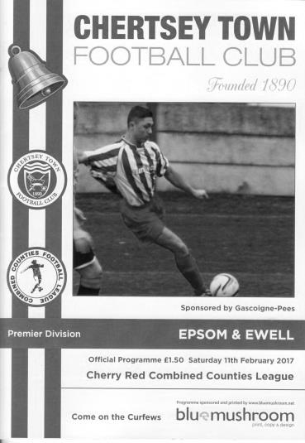
Clinical Salts overwhelm Curfews

Matches against Chertsey Town have almost always been difficult ones. Indeed they had won 25 of our previous 48 meetings. But the times are changing and this comfortable win was our third in a row and our fourth straight win at Alwyns Lane. To use the word "comfortable" would indicate that we had won without having to get out of second gear, but this was definitely not the case here. Our work rate throughout this match was superb and from the 15th minute when we went ahead there was only ever going to be one winner in this match as we totally snuffed out our opponents, denying them space to create a single threat of note over the ninety minutes.

Our opponents had been in good form although had suffered a narrow defeat to Walton & Hersham four days before this match. having said that, if there was such a thing as a good time to play a team, then maybe this was it. Although we had three absences in Alex McKay, Rob Hendry and Jason Nwachukwu, Chertsey were missing their main attacking threat of Andy Crossley and in the absence of regular keeper Chico Ramos, it was outfield player Marcus Mealing who drew the short straw for his first appearance of the season between the posts. However, in thirty-five years of watching football at this level I have never seen such an excellent performance by a "non-keeper" before as he kept the score down with a string of superb saves, two of which were world class.

We made two changes to the eleven that started in the win against Badshot Lea with Adam Heagney and Daryl Cooper-Smith returning to the starting line-up and both made many contributions. I'm pleased to report that Cooper-Smith has also returned to goal scoring form and it took him just fifteen minutes to open his account for the afternoon. A clever ball over the top of the defence enabled Jordan Gallagher through on goal but from the edge of the area his shot was half blocked by the advancing Mealing. Gallagher raced after the loose ball before it went out for a corner and cut it back to Cooper-Smith who lashed the ball at goal from just six yards only to find his shot blocked brilliantly by Mealing. Fortunately the ball dropped back at our man's feet and he drilled the ball into the net from close range.

We had been on top going down the Alwyns Lane slope, but from this point onwards we took control of the game completely. Matt Farrell and the particularly impressive Agi Panayiotou covered every inch and protected our defence really well. On the rare occasions our defence was tested it passed with flying colours. Reisse Griffin on the left and James Taylor on the right both played well and were also starting to get involved in some of the attacking play too. In the 34th minute Heagney laid the ball back for Taylor to deliver a cross and Cooper-Smith beat Mealing in the air to it, sending his header towards goal where former Salt Steve Newman, sporting a haircut that was vintage 1983 for those of you who remember the Kajagoogoo era, headed the ball away for a corner.

From the corner a minute later we extended our lead. Matt Ferdinando's delivery somehow eluded everyone and fell to the feet of Cooper-Smith at the far post, where he executed a quick drag back and poke of the ball just inside Mealing's near post before he could react to it. (see programme front cover picture)He showed really quick feet and it was reminiscent of former striker Robbie Burns, although even Robbie is not scoring at this rate as this was Cooper-Smith's 28th goal of the season in just 32 appearances. Moments later he nearly had his hat trick after controlling a cross and striking at goal from just ten yards out but Mealing made another fine save to deflect the ball for a corner. In the 40th minute, Heagney almost celebrated his 20th birthday with his first goal for the club as he let fly with a screamer with the outside of his foot from 20 yards but Mealing was able to tip the ball over the bar at full stretch.

As the half ended a Panayiotou corner was flicked on and met at the far post by a great Craig Hastings volley, but Ben Geraughty managed to stick out a leg to divert the ball up and away for a corner. Moments later Taylor joined the attack again but fell awkwardly and limped off after bashing one knee against another. He would return for the second half. In the meantime the ten remaining players scored a third goal in the second minute of injury time when Ferdinando turned provider again, this time to Gallagher out on the left where he simply cut inside Newman and drilled the ball low and inside Mealing's right hand post.

Maybe Newman was already injured by this point as he did not return for the second half and at 3-0 up the points looked secure as long as we didn't concede early in the second half and hand the home team any momentum. They came at us down the hill and some smart interchange on the edge of the box resulted in Chertsey's only real shot in anger of the match in the 47th minute but the shot was straight at Michael Eacott who parried the ball away.

We picked up the pace again soon after this and were back on the attack. Ferdinando was cynically taken out by Geraughty on the edge of the box and was maybe fortunate to receive just a warning. Ferdinando was soon on the end of a lay-off from Cooper-Smith but his shot from twenty yards was deflected wide. If anything though the second half was more even. They were still not getting any space to work with but we looked slightly less threatening also. Still as the game continued we still looked the more likely to score and in the 85th minute I thought we had done just that after substitute Ali Dewar was set up by our other substitute Matt Tanton on the left. Dewar cut the ball back for Farrell just inside the box where he unleashed a piledriver heading straight for the roof of the net but Mealing got a strong hand up to somehow divert the ball over the bar. It was one of the best saves I have seen all season.

Directly from the corner Dan Dean was unfortunate to see his header loop back off the crossbar and away and the last thing I wrote in my notebook related to a Chertsey free kick in the middle of the park that their player put straight out of play for an Epsom throw. It was that sort of day for the opposition, but the main reason they struggled so much was due to a great team performance by our boys; the third in a row, and after a bit of a blip around the New Year we appear to have found our form once again. Just as well as we have some very tough fixtures coming up, but in the meantime we are up to fifth place again and a top four finish or even higher are still well within our sights.

Epsom and Ewell: Michael Eacott, James Taylor, Reisse Griffin, Craig Hastings, Dan Dean ©, Savvas 'Agi' Panayiotou, Jordan Gallagher, Matt Farrell,
Daryl Cooper-Smith, Matt Ferdinando, Adam Heagney

Subs: Ali Dewar for Ferdinando (74), Matt Tanton for Taylor (81)

Westfield F.C. – History
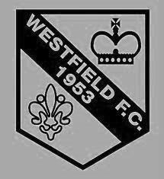
The Club was formed in 1953 as Westfield Boys Club playing in the Woking and District League and also running a youth team. From the start the Club had success in the competitions entered. Among the trophy’s won in the early years were the Surrey Youth Invitation Cup in 1953/54, the Surrey Junior Charity Cup in 1954/55 and 1955/56, the Surrey Junior Cup at the first attempt in 1955/56 and the Surrey Youth Cup in 1956/57.

Following several seasons in local league football the Club made the break into Surrey Intermediate Football using the present ground at Woking Park, Kingfield. Successes soon came and, after becoming League Champions and League Cup winners on several occasions in the subsequent seasons, the Club decided to apply for senior status.

The application was accepted in 1964 and after one season in the Parthenon League, Westfield met the necessary ground grading requirements and joined the Surrey Senior League.

Westfield’s future success in senior football sprang from their ability to attract the best local youngsters and they were successful in winning the Surrey Youth Cup again in 1966/67 and 1969/70 and the Surrey Youth Shield in 1969/70 and 1970/71. This talent matured and there followed three tremendous seasons for the senior side when they won the Surrey Senior League Cup in 1971/72, followed by the League and Cup double in 1972/73 and the League Championship again in 1973/74.

The Surrey Senior League was disbanded and reformed as the Combined Counties Football League in 1978 and Westfield became founder members and retained membership to date. Success, however, has been more difficult to achieve and in recent times the closest the senior team has come to honours was in 1989/90 when they lost the final of the Combined Counties League Cup to Hartley Wintney in extra time.

Season 2000/01 saw the Club enter the Carlsberg FA Vase for the first time, performing beyond expectations before losing in the Fourth Round to Ryman League Arlesey Town, on the way beating Wantage Town, Lewes and Bowers United.

Westfield continued to compete at youth level and they won the Combined Counties Youth League Cup in 1991/92 as well as being runners-up in the League.

Following the installation of floodlights in 1998 the U18 team joined the Southern Youth Floodlight League as members of the Western Division. The Club also run an U16 team playing in the West Surrey Youth League.

First Eleven Appearances 2016/17 - (max 41)
Name | Debut | 2016/17 |  |  |  | Career Totals
 |  | App | Sub | Total | Goals | App | Sub | Total | Goals
CLARK-GLEAVE Charlie* | 23/08/2016 | 3 | 2 | 5 | 0 | 3 | 2 | 5 | 0
COOPER-SMITH Daryl | 03/01/2015 | 27 | 5 | 32 | 29 | 57 | 13 | 70 | 49
DEAN Dan | 02/08/2014 | 30 | 2 | 32 | 0 | 98 | 6 | 104 | 2
DEWAR Ali | 29/10/2011 | 0 | 4 | 4 | 0 | 55 | 39 | 94 | 10
EACOTT Michael | 02/08/2014 | 33 | 0 | 33 | 0 | 118 | 1 | 119 | 0
FARRELL Matt | 02/08/2014 | 37 | 0 | 37 | 14 | 123 | 4 | 127 | 32
FERDINANDO Matt | 20/09/2014 | 23 | 7 | 30 | 8 | 76 | 13 | 89 | 22
GALLAGHER Jordan | 07/08/2016 | 27 | 12 | 39 | 11 | 27 | 12 | 39 | 11
GRIFFIN Reisse | 08/08/2015 | 31 | 6 | 37 | 2 | 59 | 12 | 71 | 4
HASTINGS Craig | 08/08/2015 | 27 | 7 | 34 | 2 | 64 | 11 | 75 | 2
HEAGNEY Adam | 16/08/2016 | 26 | 7 | 33 | 0 | 26 | 7 | 33 | 0
HENDRY Rob | 08/08/2015 | 29 | 7 | 36 | 7 | 59 | 18 | 77 | 19
MCKAY Alex | 20/12/2008 | 18 | 4 | 22 | 3 | 126 | 34 | 160 | 11
NEALE Tom* | 13/10/2015 | 6 | 5 | 11 | 7 | 22 | 24 | 46 | 17
NORTH Rhys | 16/08/2015 | 3 | 2 | 5 | 0 | 20 | 9 | 29 | 1
NWACHUKWU Jason | 01/10/2016 | 10 | 10 | 20 | 1 | 10 | 10 | 20 | 1
PANAYIOTOU Savvas | 03/01/2015 | 33 | 4 | 37 | 4 | 65 | 12 | 77 | 11
PRICE Matt* | 23/08/2016 | 2 | 0 | 2 | 1 | 2 | 0 | 2 | 1
ROBINSON Sam* | 22/10/2011 | 7 | 1 | 8 | 1 | 61 | 6 | 67 | 14
ROSE Daniel | 25/10/2016 | 2 | 5 | 7 | 0 | 2 | 5 | 7 | 0
SALEH Mennar* | 24/09/2016 | 0 | 2 | 2 | 0 | 0 | 2 | 2 | 0
SMITH Matt | 08/08/2009 | 0 | 2 | 2 | 1 | 91 | 45 | 136 | 11
TANTON Matt | 02/08/2014 | 32 | 2 | 34 | 1 | 89 | 6 | 95 | 3
TAYLOR James | 26/08/2013 | 33 | 3 | 36 | 2 | 119 | 15 | 134 | 8
THOMPSON Elliott | 09/02/2016 | 3 | 0 | 3 | 1 | 7 | 9 | 16 | 1
TURPIE Alistair | 31/03/2016 | 8 | 1 | 9 | 0 | 10 | 1 | 11 | 0
WATRET Jack* | 02/08/2016 | 1 | 0 | 1 | 0 | 1 | 0 | 1 | 0
* player has left the club

Club Records - 18th February
Date | Day | Competition |  | Opponents |  | Scorers
18/02/28 | Sat | Surrey Senior Cup QF | A | Summerstown | 1-5 | F.Watts
18/02/33 | Sat | London League | A | Tilbury | 0-0
18/02/39 | Sat | London League | A | Grays Athletic | 1-0 | J.Jones
18/02/50 | Sat | Corinthian League | A | Worthing | 0-3
18/02/61 | Sat | Corinthian League | A | Chesham United | 0-3
18/02/67 | Sat | Athenian League 2 | A | Herne Bay | 0-6
18/02/78 | Sat | Isthmian League 2 | A | Letchworth Garden City | 3-2 | T.Tuite (3)
18/02/84 | Sat | Isthmian League 1 | A | Oxford City | 1-1 | A.Morton
18/02/89 | Sat | Isthmian League 2 South | A | Egham Town | 2-1 | C.Hadingham (2 pens)
18/02/95 | Sat | Isthmian League 3 | A | Lewes | 4-0 | M.Laverty, T.Hoy (pen), T.Smith, S.Miller
18/02/12 | Sat | Combined Counties  Premier Division | A | Horley Town | 1-3 | N.Ayling
Historical Decades
Date | Day | Competition |  | Opponents |  | Scorers
90 years ago – Epsom Town F.C.
19/02/27 | Sat | Surrey Senior League | A | Godalming | 5-2 | R.Marlow (2), W.Challis, F.Behn, J.Parr
80 years ago – Epsom F.C.
20/02/37 | Sat | London League | H | Royal Naval Depot (Chatham) | 5-2 | T.Dunne, E.George, J.Jones (pen), T.Rochester, H.Pullen
70 years ago – Epsom F.C.
15/02/47 | Sat | London League | H | Guildford City Reserves | 2-4 | F.Taylor, G.Brogdale
60 years ago – Epsom F.C.
16/02/57 | Sat | Surrey Senior Cup QF | H | Dulwich Hamlet | 5-3 | J.Bangs (2), J.Sorensen, D.Hermitage, o.g.
50 years ago – Epsom & Ewell F.C.
18/02/67 | Sat | Athenian League 2 | A | Herne Bay | 0-6
40 years ago – Epsom & Ewell F.C.
19/02/77 | Sat | Athenian League 1 | A | Grays Athletic | 0-1
30 years ago – Epsom & Ewell F.C.
21/02/87 | Sat | Isthmian League 1 | A | Finchley | 2-1 | J.Rains, J.Richardson (pen)
20 years ago – Epsom & Ewell F.C.
15/02/97 | Sat | Isthmian League 3 | H | Tring Town | 4-3 | M.Jones (2), T.Boorman, S.Miller
10 years ago – Epsom & Ewell F.C.
17/02/07 | Sat | Combined Counties  Premier Division | H | Sandhurst Town | 2-1 | P.N'gbale, S.Murphy

History Corner - 18th February
The keen eyed amongst you may have noticed from the previous page that despite being a Senior status club for nearly 93 years, we have NEVER played a home match on this particular day before. All eleven previous matches have been away fixtures!!

95 years ago today we did have a home match, but only as a Junior status club when we hosted Epsom Brotherhood who were our local rivals, playing down the road at the old Brickworks site which was in East Street, very close to where the Kiln Lane site is now. It is believed that this was one of our first matches at our new ground within the Horton Hospital Playing fields, although we lost this Sutton & District League match by two goals to nil. It would be the last competitive home match we would lose until December 1924; a span of two and a half years.

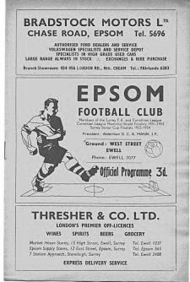
90 years ago this week Reg Marlow failed us! Having scored five hat tricks in a row we visited Godalming’s ground for a Surrey Senior League match and he only scored twice!! Fortunately, we still won 5-2 on our way to a Surrey Senior League and Charity Cup double as Jack Parr, Wilfred “Bronk” Challis and Freddie Behn also hit the target.

89 years ago today we visited Summerstown for a Surrey Senior Cup Quarter-Final full of confidence. We were top of the London League and about to win the title, while the Town were at the foot of the next step up, the Athenian League. We were off to a flyer with Fred Watts putting us ahead in the first couple of minutes but on a pitch where the mud was ankle deep, we were unable to play our style of football and found ourselves 3-1 down at the interval, eventually losing 5-1. We would have to wait 12 more months before reaching the Surrey Senior Cup Final, but by then Summerstown had ceased to exist as they lost their ground in Garratt Lane and folded at the end of the season. It’s hard to believe that their demise was met with such apathy as they used to command regular crowds of 2,000 or more. All that remained was the Grand Stand which was purchased by Wealdstone and was situated at Lower Mead where it would watch over much success, including their great Conference and F.A. Trophy winning team of 1984/85. Players like Stuart Pearce and a young Vinnie Jones played there frequently and the stand would survive until it too was demolished along with the ground in the early nineties.

60 years ago this week we defeated the mighty Dulwich Hamlet in the Surrey Senior Cup at West Street. (see programme pictured) The 1956/57 season contained much promise as we were looking for a League and Cup double in the Corinthian League going into the final week of the season only to lose the Final and three League matches all in one week to finish fourth. Earlier in the season we had progressed to the Semi-Final of the Surrey Senior Cup too where we were narrowly defeated by a fluke goal by Wimbledon. To get there we battered Isthmian League Dulwich by five goals to three, registering 100 goals for the season during this match. Johnny Bangs scored twice on his way to a personal tally of 53 this term along with Jan Sorensen, Dave Hermitage and an own goal.

39 years ago today Tommy Tuite scored three times to lead us past Letchworth Garden City on our way to the Isthmian League Division Two title. They weren’t a bad side back then and contained a promising youngster by the name of Imre Varadi who would go on to have much success at Sheffield Wednesday in particular.

Centre page for results

Centre page for results

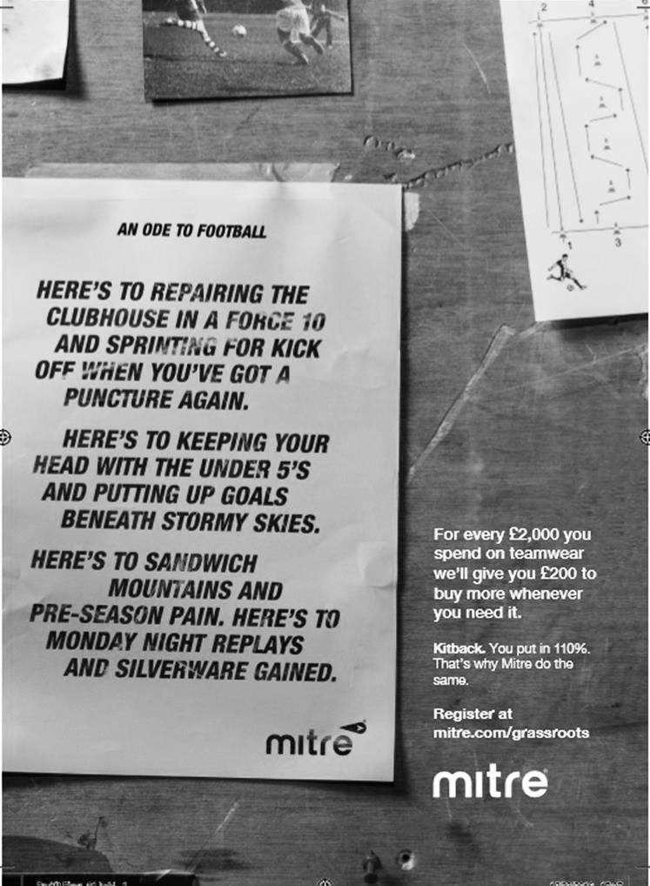

My Club Betting
We can now announce that Epsom & Ewell F.C.
now have our own betting site!

If you like to have a bet, this is most definitely for you.

In conjunction with MyClubBetting.com you can now access all the regular markets that you might do regularly with just a click on our website.

But why would you do this? Many of you already might have apps that you currently use.

The main reason is that you would benefit the club by doing so, but at the same time would not lose out yourselves. Their odds are at least comparable and in many cases better than the other bookmakers out there and by registering with us, the club would make 20% of any cumulative losses and with enough usage, we would qualify for other fairly substantial club benefits.

If you win the bet that you place, that is fantastic news, but whichever company you use currently would keep 100% of any losses. This way our club can receive a nice lump sum in the event that you are unlucky.

For example. If we have 20 people signed up and they lost £25 over the month each, our club would receive £100 back out of the £500 lost.

So just visit: https://eefc.myclubbetting.co.uk/ and join the club!

Combined Counties League Premier Division
Opponents All-time Records
incl Tuesday 14th  February | P | W | D | L | F | A | PPG | GD | Best  Win | Worst  Loss
Bedfont & Feltham | 1 | 1 | 0 | 0 | 9 | 2 | 3.00 | +7 | 9-2 | X
Spelthorne Sports* | 6 | 5 | 1 | 0 | 15 | 6 | 2.67 | +10 | 6-2 | X
Sutton Common Rovers | 12 | 9 | 2 | 1 | 30 | 14 | 2.42 | +16 | 4-0 | 1-4
Horley Town | 29 | 20 | 5 | 4 | 65 | 30 | 2.24 | +35 | 6-0 | 1-3
Colliers Wood United | 22 | 14 | 2 | 6 | 45 | 33 | 2.00 | +12 | 4-0 | 0-5
Bedfont Sports | 10 | 6 | 2 | 2 | 18 | 11 | 2.00 | +7 | 5-1 | 0-4
Abbey Rangers | 3 | 2 | 0 | 1 | 10 | 4 | 2.00 | +6 | 7-1 | 2-3
Guildford City | 18 | 11 | 1 | 6 | 35 | 22 | 1.89 | +13 | 5-1 | 1-5
Westfield | 19 | 11 | 3 | 5 | 40 | 31 | 1.89 | +9 | 6-1 | 0-4
Farnham Town | 14 | 8 | 2 | 4 | 25 | 23 | 1.86 | +2 | 3-1 | 1-4
Knaphill | 7 | 4 | 1 | 2 | 15 | 8 | 1.86 | +7 | 4-0 | 1-2
Badshot Lea | 19 | 9 | 3 | 7 | 39 | 36 | 1.74 | +3 | 4-1 | 0-4
Walton & Hersham | 51 | 25 | 10 | 16 | 104 | 98 | 1.67 | +6 | 6-0 | 0-8
Hanworth Villa | 17 | 8 | 4 | 5 | 38 | 27 | 1.65 | +11 | 5-0 | 1-4
Raynes Park Vale | 28 | 13 | 7 | 8 | 59 | 38 | 1.64 | +21 | 6-1 | 0-2
Camberley Town* | 89 | 38 | 22 | 28 | 158 | 123 | 1.52 | +35 | 9-1 | 0-4
Hartley Wintney | 11 | 4 | 3 | 4 | 26 | 20 | 1.36 | +6 | 5-0 | 2-4
Windsor | 49 | 19 | 12 | 18 | 90 | 90 | 1.41 | 0 | 4-0 | 0-6
Chertsey Town | 49 | 19 | 5 | 25 | 75 | 87 | 1.27 | -12 | 3-0 | 0-7
North Greenford United | 11 | 3 | 2 | 6 | 15 | 20 | 1.00 | -5 | 3-0 | 1-4
CB Hounslow United | 3 | 1 | 0 | 2 | 4 | 7 | 1.00 | -3 | 2-0 | 1-5
AFC Hayes | 10 | 2 | 3 | 5 | 18 | 18 | 0.90 | +1 | 7-0 | 0-3
* includes one abandoned match v Camberley and one loss on penalties v Spelthorne

Surrey Senior Cup
Third Round
Whyteleafe | 2-0 | Egham Town
Badshot Lea | 0-2 | Raynes Park Vale
Epsom & Ewell | 1-2 | Guildford City
Dorking Wanderers | 1-1 8p7 | Sutton Common Rovers
Chertsey Town | 1-0 | Kingstonian
Woking | 2-0 | Leatherhead
Merstham | 5-1 | Walton & Hersham
Tooting & Mitcham United | 0-1 | Knaphill
Quarter Final
Guildford City | 2-1 | Raynes Park Vale
Chertsey Town | 28/2 | Dorking Wanderers
Merstham | 2-1 | Whyteleafe
Woking | 21/2 | Knaphill

F.A. Vase
Fifth Round – 28th / 29th January
Cleethorpes Town | 3-2 | Atherton Collieries
Southall | 4-2 | Exmouth Town
Bromsgrove Sporting | 2-1 | Bristol Manor Farm
Crowborough Athletic | 3-6 | Coleshill Town
Hinckley AFC | 3-4+ | Buckland Athletic
Newport Pagnell Town | 3-2+ | Sunderland RCA
Ely City | 0-3 | Sporting Khalsa
Team Solent | 2-5 | South Shields
Quarter - Final – 18th February
South Shields | V | Newport Pagnell Town
Southall | V | Cleethorpes Town
Bromsgrove Sporting | V | Buckland Athletic
Coleshill Town | V | Sporting Khalsa

CCL Premier Division Club Directory
ABBEY RANGERS Telephone: 01932-422962 - Ground: Addlestone Moor, Addlestone, Surrey KT15 2QH - Colours: Black & White Stripes/Black/Black

A.F.C. HAYES Telephone: 0208-845-0110 - Ground: Farm Park, Kingshill Avenue, Hayes, Middx. UB4 8DD - Colours: Blue and White Stripes/Blue/Blue

BADSHOT LEA Telephone: 01252-320385 - Ground: Ash United FC, Shawfield Stadium, Youngs Drive, Shawfields Road, Ash, Hampshire. GU12 6RE - Colours: Claret/White/Claret

BEDFONT & FELTHAM Telephone: 0208 890 7264 - Ground: The Orchard, Hatton Road, Bedfont, Middx TW14 9QT - Colours: Yellow & Blue/Blue/Blue

BEDFONT SPORTS Telephone: 0208-831-9067 - Ground: Bedfont Sports Club, Hatton Road, Bedfont, Middx TW14 8JA - Colours: Red & Black Hoops/Black/Red & Black Hoops

CAMBERLEY TOWN Telephone: 01276-65392 - Ground: Krooner Park, Wilton Road, Camberley, Surrey. GU15 2QW - Colours: Red & White Stripes/Blue/Red

CB HOUNSLOW UNITED Telephone: 0208 890 7264 - Ground: The Orchard, Hatton Road, Bedfont, Middx TW14 9QT - Colours: Green/Black/Green

CHERTSEY TOWN Telephone: 01932-561774 - Ground: Alwyns Lane, Chertsey, Surrey. KT16 9DW - Colours: Royal Blue & White Stripes/Royal Blue/Royal Blue

COLLIERS WOOD UNITED Telephone: 0208-942 8062 - Ground: Wibbandune Sports Ground, Robin Hood Way, Wimbledon. SW20 0AA - Colours: Blue & Black Stripes/Black/Black
EPSOM & EWELL Telephone: 01737-553250 - Ground: Chipstead FC, High Road, Chipstead, Surrey. CR5 3SF - Colours: Royal Blue & White Hoops/Royal Blue/Royal Blue

FARNHAM TOWN Telephone: 01252-715305 Ground: Memorial Ground, Babbs Mead, West Street, Farnham, Surrey. GU9 7DY Colours: - Claret & Sky Blue /White/ Claret & Sky Blue

GUILDFORD CITY Telephone: 01483-443322 - Ground: The Spectrum, Parkway, Guildford, Surrey. GU1 1UP - Colours: Red & White Stripes/Black/Black

HANWORTH VILLA Telephone: 0208-831-9391 - Ground: Rectory Meadows, Park Road, off Hounslow Road, Hanworth, Middlesex. TW13 6PN - Colours: Red & White Stripes/Black/Black

HARTLEY WINTNEY Telephone: 01252-843586 - Ground: Memorial Playing Fields, Green Lane, Hartley Wintney, Hants RG27 8DL - Colours: Orange & Black/ Orange /Orange

HORLEY TOWN Telephone: 01293-822000 - Ground: The New Defence, Anderson Way, Court Lodge Road, Horley, Surrey. RH6 8SP - Colours: Claret & Sky Blue/Claret/Claret

KNAPHILL Telephone: 01483-475150 - Ground: Brookwood Country Park, Redding Way, Lower Guildford Road, Knaphill, Surrey. GU21 2AY - Colours: Red/Black/Red

NORTH GREENFORD UNITED Telephone: 0208 422 8923 - Ground: Berkeley Fields, Berkeley Avenue, Greenford, Middx UB6 0NX - Colours: Royal Blue & White/Royal Blue/Royal Blue

SUTTON COMMON ROVERS Telephone: 01932-866386 - Ground: Sutton United FC, Gander Green Lane, Sutton, Surrey SM1 2EY - Colours: Yellow/Black/Black

RAYNES PARK VALE Telephone: 020-8540-8843 - Ground: Prince Georges Playing Field, Grand Drive, Raynes Park, London. SW20 9NB - Colours: Blue/Blue/Red

SPELTHORNE SPORTS Telephone: 01932-961055 - Ground: Spelthorne Sports Club, Staines Road, Ashford Common, Ashford, Middx. TW15 1RY - Colours: Light & Dark Blue/Dark Blue/Light Blue

WALTON & HERSHAM Telephone: 01932 245263 - Ground: Stompond Lane, Walton on Thames, Surrey KT12 1HF - Colours: Red/Red/Red

WESTFIELD Telephone: 01483-771106 - Ground: Woking Park, Kingfield Road, Woking, Surrey. GU22 9BA - Colours: Yellow/Black/Black

WINDSOR Telephone: 01753-860656 - Ground: Stag Meadow, St Leonards Road, Windsor, Berks SL4 3DR - Colours: Red/Red/Red

From behind the goal
CB Hounslow United 0-2 Epsom & Ewell
Combined Counties League - Premier Division - Tuesday 14th February 2017

Hard working performance bears fruit at the Orchard

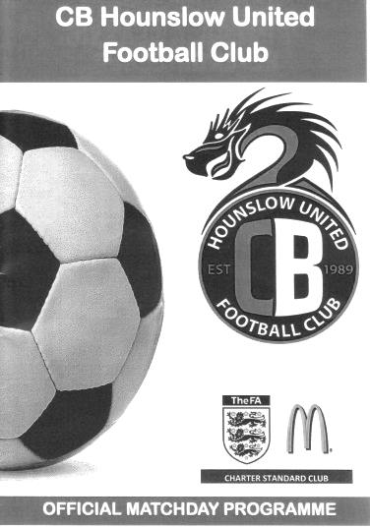
We have no idea where we will finish this season and in all honesty this match may not even be remembered for too long, certainly when compared to our previous visit to the Orchard on the opening day of the season when we won 9-2 against Bedfont & Feltham, but even so, this result was significant and may even help us earn a top four finish. This was a superb all round performance; our fourth in a row, but it was so much more than that when considering the number of players that were unavailable.

For some reason we seem to have trouble fielding a team during the half term period. We only had one fit outfield player on the bench at Raynes Park in October and this was the case once again today as we took on Bedfont & Feltham's tenants, CB Hounslow United. However, selection was more difficult this time as three of our regular centre halves were unavailable. Alex McKay and James Taylor were away while Craig Hastings was nursing a sore calf and sat on the bench with no intention of coming on! Reisse Griffin stepped up to play alongside Dan Dean in the centre of defence and the pair of them were rarely troubled. Adam Heagney reverted to right back while the returning Rhys North probably wasn't expecting to start at left back, but square pegs in round holes was the order of the day.

Up front Jason Nwachukwu was available to play and started on the right side of midfield while the remainder of the team was the same as that which had played so well at Chertsey Town on Saturday. Against a Hounslow team that had won at Knaphill on the same day it was clear that this was going to be a difficult match, without even mentioning that they are currently the only team to have won in the League at High Road, 5-1 back in August.

The hosts started confidently, passing the ball around at the back and looking quite composed while doing so. However, this slow style of build up suits our midfield terriers as we have time to get back into shape and Agi Panayiotou and Matt Farrell were all over the place as we harried and pressed our opponents on what was quite a bobbly pitch. This became relevant in the 12th minute as Matt Ferdinando seized upon a poor touch by a defender and broke through on goal, drawing the keeper Jonathan Rolfe and passing the ball across for Daryl Cooper-Smith to side foot the ball into the empty net from close range for his 29th goal of the season.

Ferdinando had a try of his own a couple of minutes later with a shot from the edge of the area but a deflection took the pace off the ball which was then headed back to Rolfe by a team mate. CB Hounslow responded with a couple of free kicks on the edge of the area, but they came to little and on the counter attack Nwachukwu fed Ferdinando and his whipped cross was struck at goal by

Cooper-Smith from the edge of the area, requiring Rolfe to get down low to tip the ball around the post for a corner. Although that came to nothing we nearly got a second when Cooper-Smith had another try from distance but pulled the shot a little and it went right into the path of Ferdinando but under pressure he was only able to get a faint touch to the ball and couldn't direct it on target.

Another free kick from the edge of the area required a full stretch save from Michael Eacott and on the half hour a break down the right ended with a powerful shot being well blocked by the big fella. In reality, although the home side were doing much of the pressing they weren't really creating much of concern and those two opportunities represented their only chances in the half. In response Heagney got forward on the right and put in a dangerous low cross that was diverted away from the incoming Cooper-Smith by the outstretched leg of Hounslow Captain Harry Driver.

The half ended with an unexpected bonus as we earned a corner in the 45th minute. Ferdinando sent a short corner to Panayiotou who returned it to Ferdinando just inside the box and he drilled it into the net. It looked at first as if the shot would be blocked by a defender's foot but the ball bounced straight over it and caught Rolfe out at his near post as a result.

So, some six months after our big win, we had achieved something that we failed to do that night in scoring goals in the far net! However, well aware that our opponents that night couldn't hold a 2-0 lead we knew this second forty five minutes would tell us much about our character and I'm pleased to report that we passed the test with flying colours.

Jordan Gallagher nearly extended our lead in the opening minute after cutting in but his shot was too close to Rolfe and looking back, this was quite possibly the best chance of the half. Ferdinando nearly executed a perfect chip from 25 yards but the tall Rolfe was just able to get back to tip the ball over the bar. We had a small scare just after hour when a right wing cross appeared to be flicked on but our defenders were there to clear the danger once again.

We had further tests to come though and would have to play the final twenty five minutes with ten men as Cooper-Smith retaliated against Stuart Bamford and received a red card as a result. It was a little disappointing that the officials didn't see the original offence or consider why our player might have reacted like that, but we would have to see out the match without our main striker. Shortly after this North tweaked a hamstring and had to come off, being replaced by Ali Dewar. Still we looked as likely to score as our opponents, and Gallagher latched on to a long Eacott kick but his shot at goal was weak with Ferdinando waiting.

Then we went down to nine men for a while as Farrell was asked to leave the field to receive treatment for a cut on his head. Incredibly we nearly made it 3-0 during his absence when Ferdinando received a long ball which he then turned into an attempt on goal from 35 yards but Rolfe recovered really well to get a hand on the ball and concede the corner. From the Panayiotou corner Dean got ahead of his marker only to see his powerful header cannon off Rolfe's left hand post and away to safety.

After seven minutes of correctly added injury time, the final whistle blew and we were able to celebrate a fine win. It may not have been pretty at times but it was certainly effective and if we are able to secure a top four finish then it is important not to forget results like this one which marked our fourth straight win, all of which have been impressive for different reasons. File this one under "achievements despite adversity"!

Epsom and Ewell: Michael Eacott, Adam Heagney, Rhys North, Reisse Griffin, Dan Dean ©, Savvas 'Agi' Panayiotou, Jordan Gallagher, Matt Farrell,
Daryl Cooper-Smith, Matt Ferdinando, Jason Nwachukwu

Subs: Ali Dewar for North (75)

Player Sponsorship
Here is the current list for the 2016/17 season showing all of our players and Management that are available for sponsorship.

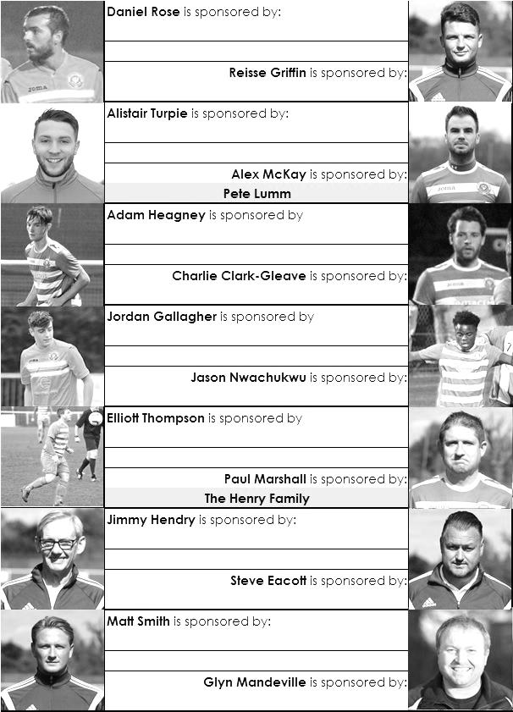

Sponsorship costs just £40 and it is easy to do. Just select a player who has not been previously sponsored and let a Committee Member know that you would like to sponsor them. Beware though. Until we have received the money it is possible for someone to jump in front of you, so don’t delay, sponsor today!
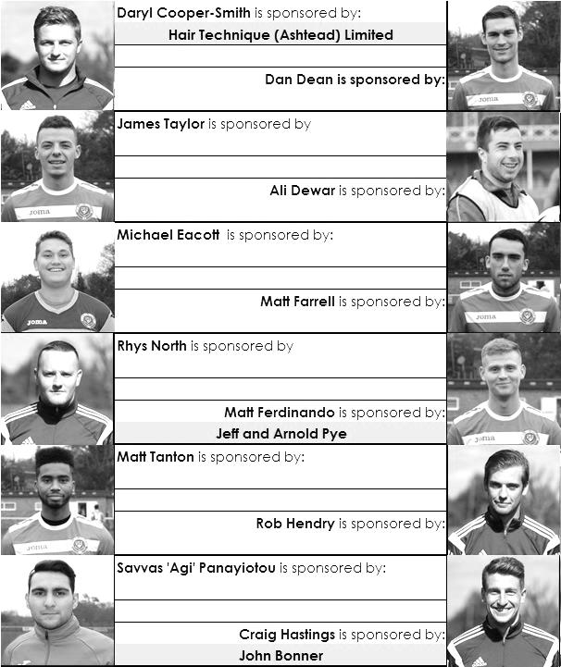

Match and Ball Sponsorships – 2016/17
Opponent | Date | Match Sponsor | Ball Sponsor
Gravesham Borough | 07/08/16 | Club President - Stella Lamont
Gravesham Borough | 07/08/16 | Relocation Committee Member - Mike Lovett
CB Hounslow United | 16/08/16 | EEFC Management Committee
Abbey Rangers | 23/08/16 | Steve & Geoff Dyke
Horley Town (11.30am) | 29/08/16 | In Memory of Chris Henry
Abbey Rangers (LC) | 06/09/16 | Paul Merritt
Camberley Town | 10/09/16 | Building Shop Ltd
Knaphill | 24/09/16 | EEFC Holding Company Director – Pete Lumm
Bridon Ropes (FAV) | 22/10/16 | George and Joseph Saunders
Sutton Common Rovers | 08/11/15 | Alex McKay Senior
Abbey Rangers (FAV) | 13/11/16 | EEFC Holding Company Director – Dave Ellins
Windsor | 15/11/16 | In Memory of Wally Dyke
Bedfont Sports | 19/11/16 | John Bonner
AFC Hayes | 26/11/16 | Jack Jarman
Chipstead (SSC / DWT) | 06/12/16 | Trevor Stotten
Hanworth Villa | 13/12/16 | Roger and Carol Farrell
Chertsey Town | 17/12/16
Raynes Park Vale (11.30am) | 27/12/16 | In memory of Dave and Liz Marshall
Spelthorne Sports | 07/01/17 | Building Shop Ltd
Guildford City (SSC) | 10/01/17 | Super Six Winner – Rita Christian
Guildford City | 17/01/17
Badshot Lea | 04/02/17
Westfield | 18/02/17 | Tony Coome
Walton & Hersham | 04/03/17
Bedfont & Feltham | 07/03/17 | Programme Editor - Richard Lambert
Hartley Wintney | 18/03/17
Farnham Town | 25/03/17
Colliers Wood United (1pm) | 14/04/17 | Good Friday match – make a note!
North Greenford United | 22/04/17 | Club President - Stella Lamont
For League, League Cup and Surrey Senior Cup Matches:
Match sponsorship - £40.00 Match ball sponsorship - £25.00. Combined £55.00.
For F.A. Cup and F.A. Vase matches:
Match sponsorship - £50.00 Match ball sponsorship - £30.00. Combined £65.00.

Sponsorship includes: (x2 for match, x3 for match and ball)

Admission, programmes, hospitality and advertising and mascot for the day (if required).
If you are interested, just speak to a Committee Member, or drop me an email at: richard.c.lambert@gmail.com

We also thank our Sponsors INTERCEM and G4 Group

Salts Super Six Predictor
The Salts Super Six Predictor is live again for today’s match and the tickets are on sale at today’s game to the left of the gate. The matches are to be played today.

The jackpot is already up to £406 so what are you waiting for!

The competition is easy to play! To win, you simply need to predict the results of six matches correctly from the three options, fill in the form and make sure it is back with our seller before the deadline on the ticket. The latest fixtures are shown below.

If you are a club regular, you just need to place your name on the sheet, although if you aren’t, then we’ll need a contact number from you too. We will announce any winners on the website within three working days, so don’t worry, we won’t miss you!

Please note that if there is more than one winner, the prize pot would be shared between the winners. All you need to do now is have a go, as many times as you like!

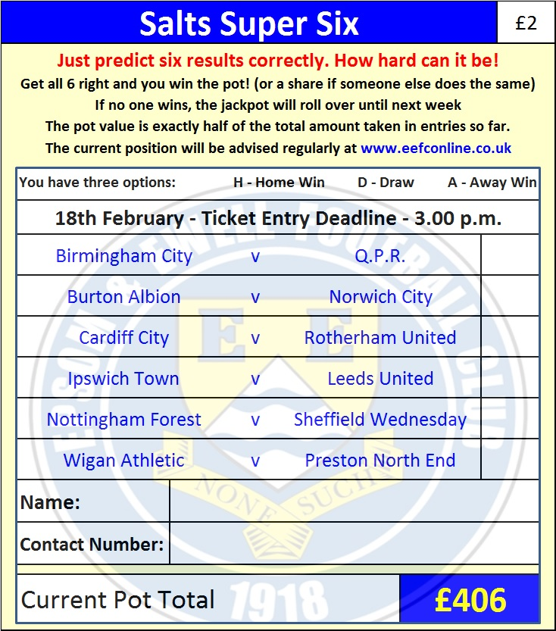
Good luck!

Combined Counties League – Premier Division
Saturday, 18th February 2017 - Kick-off 3.00 p.m.

Epsom and Ewell  (Royal Blue & White hoops) | V |  | Westfield  (Yellow and Black)
Squad | NUMBERS |  | Squad
Michael Eacott |  |  | Gary Ross
Adam Heagney |  |  | Luke Beale
Matt Tanton |  |  | Jack Battie
James Taylor |  |  | Matt Steer
© Dan Dean |  |  | Adam Bellmaine
Savvas ‘Agi’ Panayiotou |  |  | Kyle Bailey
Jordan Gallagher |  |  | Shaun Elliott
Matt Farrell |  |  | James Mariner
Rob Hendry |  |  | Dale Burnham
Matt Ferdinando |  |  | Matt Jackson
Reisse Griffin |  |  | Max Blackmore
Jason Nwachukwu |  |  | Tyrone Hemmings
Craig Hastings |  |  | Hicham Abdellah
Daryl Cooper-Smith |  |  | Ryan Marklew
Alex McKay |  |  | Aaron Watson
Ali Dewar |  |  | Karle Carder-Andrews
Alistair Turpie |  |  | James Cottee
Matt Smith
Daniel Rose
Glyn Mandeville | MANAGER |  | Tony Reid
Matt Smith | ASSISTANT |  | Lee Morris
Steve Eacott / Alex McKay/  Jimmy Hendry | COACHES / PHYSIO |  | Louis Carder-Walcott /  John Steerwood
REFEREE: M.Begley
ASSISTANTS: K.Corrick, R.Wells
Today’s match and Match Ball are kindly sponsored by
regular supporter Tony Coome

OUR NEXT VISITORS TO HIGH ROAD
Walton & Hersham
Combined Counties League – Premier Division
Saturday 4th March 2017 – 3.00 p.m.

